**Matrix: Multihop Address allocation and dynamic any-To-any Routing for 6LoWPAN**

Bruna S. Peres [bperes@dcc.ufmg.br](mailto:bperes@dcc.ufmg.br)

Otavio A. de O. Souza [oaugusto@dcc.ufmg.br](mailto:oaugusto@dcc.ufmg.br)

Bruno P. Santos [bruno](mailto:bruno.ps@dcc.ufmg.br)[.ps@dcc.ufmg.br](mailto:.ps@dcc.ufmg.br)

Marcos A. M. Vieira [mmvieir](mailto:mmvieira@dcc.ufmg.br)[a@dcc.ufmg.br](mailto:a@dcc.ufmg.br)

Edson R. A. Junior [edsonroteia@dcc.ufmg.br](mailto:edsonroteia@dcc.ufmg.br)

Luiz F. M. Vieira [lfvieir](mailto:lfvieira@dcc.ufmg.br)[a@dcc.ufmg.br](mailto:a@dcc.ufmg.br)

Olga Goussevskaia [olga@dcc.ufmg.br](mailto:olga@dcc.ufmg.br)

Antonio A.F. Loureiro [loureiro@dcc.ufmg.br](mailto:loureiro@dcc.ufmg.br)

Computer Science Department, Universidade Federal de Minas Gerais, Brazil

**ABSTRACT**

Standard routing protocols for IPv6 over Low power Wire- less Personal Area Networks (6LoWPAN) are mainly de- signed for data collection applications and work by estab- lishing a tree-based network topology, which enables pack- ets to be sent upwards, from the leaves to the root, adapting to dynamics of low-power communication links. The rout- ing tables in such unidirectional networks are very simple and small since each node just needs to maintain the ad- dress of its parent in the tree, providing the best-quality route at every moment. In this work, we propose Matrix, a platform-independent routing protocol that utilizes the ex- isting tree structure of the network to enable reliable and efficient any-to-any data traffic. Matrix uses hierarchical IPv6 address assignment in order to optimize routing ta- ble size, while preserving bidirectional routing. Moreover, it uses a local broadcast mechanism to forward messages to the right subtree when persistent node or link failures oc- cur. We implemented Matrix on TinyOS and evaluated its performance both analytically and through simulations on TOSSIM. Our results showed that the proposed protocol is superior to available protocols for 6LoWPAN, when it comes to any-to-any data communication, in terms of reliability, message efficiency, and memory footprint.

# CCS Concepts

### *•*Networks *→* Network protocol design; Network layer protocols;

**Keywords**

6LoWPAN; IPv6; CTP; RPL; any-to-any routing; fault tol- erance

Permission to make digital or hard copies of all or part of this work for personal or classroom use is granted without fee provided that copies are not made or distributed for profit or commercial advantage and that copies bear this notice and the full cita- tion on the first page. Copyrights for components of this work owned by others than ACM must be honored. Abstracting with credit is permitted. To copy otherwise, or re- publish, to post on servers or to redistribute to lists, requires prior specific permission and/or a fee. Request permissions from [permissions@acm.org.](mailto:permissions@acm.org)

# INTRODUCTION

IPv6 over Low-power Wireless Personal Area Networks (6LoWPAN1) is a working group inspired by the idea that even the smallest low-power devices should be able to run the Internet Protocol to become part of the Internet of Things. Standard routing protocols for 6LowPAN, such as CTP (Col- lection Tree Protocol [6]) and RPL (IPv6 Routing Proto- col for Low-Power and Lossy Networks [19]), have two dis- tinctive characteristics: communication devices use unstruc- tured IPv6 addresses that do not reflect the topology of the network (typically derived from their MAC addresses), and routing lacks support for any-to-any communication since it is based on distributed collection tree structures focused on bottom-up data flows (from the leaves to the root). The problem with such one-directional routing is it makes it in- efficient to build important network functions, such as con- figuration routines and reliable mechanisms to ensure the delivery of end-to-end data.

Even though CTP does not support any-to-any traffic, the specification of RPL defines two modes of operation for top- down data flows: the non-storing mode, which uses source routing, and the storing mode, in which each node maintains a routing table for all possible destinations. This requires *O*(*n*) space (where *n* is the total number of nodes), which is unfeasible for memory-constrained devices.

Some works have addressed this problem from different perspectives. In [15], the authors proposed a hierarchical IPv6 address allocation scheme, referred to as MHCL, to enable any-to-any routing by incorporating network topol- ogy information into the IPv6 address, assigned to each node in a multihop fashion. MHCL was implemented as a sub- routine of RPL and showed to enable any-to-any routing using compact routing tables. MHCL stores the IPv6 ad- dress range of the entire subtree rooted at a child node in a single routing table entry, which results in *O*(*k*) memory space, where *k* is the number of one-hop descendants of a node in the collection tree. The downside of MHCL is it was not designed to deal with network faults and dynamic net- work topologies since a message can be dropped whenever a node or link failure occurs in the address hierarchy.

In this work, we build upon the idea of using hierarchi-

*Q*c 2016 ACM. ISBN 978-1-4503-2138-9. DOI: 10.1145/1235

1We use the acronym 6LoWPAN to refer to Low power Wireless Personal Area Networks that use IPv6

cal IPv6 address allocation and propose Matrix, a routing scheme for dynamic network topologies and fault-tolerant any-to-any data flows in 6LoWPAN. Matrix assumes there is an underlying collection tree topology (provided by CTP or RPL, for instance), in which nodes have static locations, i.e., are not mobile, and links are dynamics, i.e., nodes might choose different parents according to link quality dynam- ics. Matrix uses only one-hop information in the routing tables and implements a local broadcast mechanism to for- ward messages to the right subtree when node or link failures occur.

After the network has been initialized and all nodes have received an IPv6 address range, three simultaneous distributed trees are maintained by all nodes: the collection tree (Ctree), the IPv6 address tree (IPtree), and the reverse collection tree (RCtree). Initially, any-to-any packet forwarding is per- formed using Ctree for bottom-up and IPtree for top-down data flows. Whenever a node or link fails or Ctree changes, the new link is added in the reverse direction into RCtree and is maintained as long as this topology change persists. Top-down data packets are then forwarded from IPtree to RCtree via a local broadcast. The node that receives a local- broadcast checks whether it knows the subtree of the desti- nation IPv6 address: if yes then is forwards the packet to the right subtree via RCtree and the packet continues its path in the IPtree until the final destination.

Why is this approach robust to network dynamics? Rout- ing is performed using the address hierarchy represented by the IPtree, so whenever a link or node fails, messages ad- dressed to destinations in the corresponding subtree may be lost. Matrix uses the (dynamic) reverse collection tree and the local broadcast mechanism to forward messages to the right subtree, as long as an alternative route exists. Note that this local rerouting mechanism does not guarantee that all messages will be delivered. We argue that the probabil- ity that the message will be forwarded to the appropriate subtree is high, as long as there is a valid path, due to the geometric properties of wireless networks. Our simulations showed that this intuition is, in fact, correct.

Why does this approach scale? Each node stores only one-hop neighborhood information, namely: the id of its parent in Ctree, the IPv6 address ranges of its children in the IPtree, and the IPv6 address ranges of its (temporary) children in the RCtree. Therefore, the memory footprint at each node is *O*(*k*), where *k* is the number of children at any given moment in time. The impact of such low memory footprint on the end-to-end routing success is impressive: whereas RPL delivers less than 20% of packets in some sce- narios, Matrix delivers 99% of packets successfully, without end-to-end mechanisms.

We evaluated the proposed protocol both analytically and by simulation. Even though Matrix is platform-independent, we implemented it as a subroutine of CTP on TinyOS and conducted simulations on TOSSIM. The results showed that, when it comes to any-to-any communication, Matrix presents significant gains in terms of reliability (higher any-to-any message delivery) and scalability (presenting a constant, as opposed to linear, memory complexity at each node) at a moderate cost of additional control messages, when com-

nectivity between hosts located within or outside the 6LoWPAN.

* + **Memory efficiency**: Matrix uses compact routing tables and, therefore, is scalable to very large networks.
  + **Reliability**: Matrix achieves 99% delivery without end-to-end mechanisms, and delivers *≥* 95% of end-

to-end packets when a route exists under challenging network conditions.

* + **Communication efficiency**: Matrix uses adaptive beaconing based on Trickle algorithm [11] to minimize the number of control messages in dynamic network topologies (except with node mobility).
  + **Hardware independence**: Matrix does not rely on specific radio chip features, and only assumes an un- derlying collection tree structure.
  + **IoT integration**: Matrix allocates global (and struc- tured) IPv6 addresses to all nodes, which allow nodes to act as destinations integrated into the Internet, con- tributing to the realization of the Internet of Things.

The rest of this paper is organized as follows. In Section 2 we describe the Matrix protocol design. In Section 3, we an- alyze the message complexity of the protocol. In Section 4 we present our analytical and simulation results. In Sec- tion 5 we discuss some related work. Finally, in Section 6 we present the concluding remarks.

# DESIGN OVERVIEW

The objective of Matrix is to enable any-to-any routing in an underlying data collection protocol for 6LoWPAN, such as CTP and RPL, while preserving memory and message ef- ficiency, as well as adaptability to networks topology dynam- ics2. Matrix is a network layer protocol that works together with a routing protocol. Figure 1 illustrates the protocol’s architecture, which is divided into: *routing engine* and *for- warding engine*. The routing engine is responsible for the address space partitioning and distribution, as well as rout- ing table maintenance. The forwarding engine is responsible for application packet forwarding.

Matrix is comprised of the following execution phases: **Collection tree initialization**: the collection tree (Ctree) is built by the underlying collection protocol; each node achieves a stable knowledge about who its parent is; adap- tive beaconing based on Trickle algorithm [11] is used to define stability; **Descendants convergecast, IPv6 tree broadcast**: once the collection tree is stable, the address hierarchy tree (IPtree) is built using MHCL [16]; this phase also uses adaptive beaconing to handle network dynamics; by the end of this phase, each node has received an IPv6 address range from its parent and each non-leaf node has partitioned its own address space among its children; the resulting address hierarchy is stored in the distributed IP- tree, which initially has the same topology as Ctree, but in reverse, top-down, direction. **Standard routing**: bottom- up routing is done using the collection tree, Ctree, and top- down routing is done using the address hierarchy represented

pared to other state-of-the-art protocols, such as RPL.

To sum up, Matrix achieves the following essential goals that motivated our work:

* + **Any-to-any routing**: Matrix enables end-to-end con-

2Note that Matrix is not designed to address scenarios with node mobility, but only to work with network topology dy- namics caused by changes in link quality, as well as node and link failures.

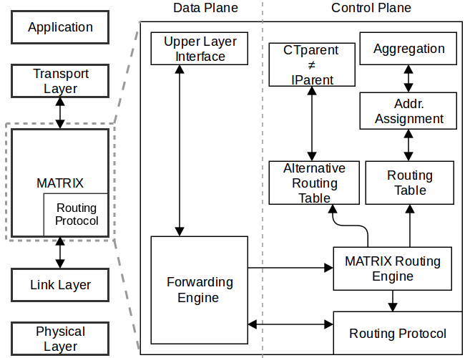

### Figure 1: Matrix protocol’s architecture.

by the IPtree; any-to-any routing is performed by combin- ing bottom-up forwarding, until the least common ancestor of sender and receiver, and then top-down forwarding until the destination. **Alternative top-down routing table upkeep**: whenever a node changes its parent in the initial collection tree, it starts sending beacons to its new parent in Ctree, requesting to upkeep an entry in its routing table with its own IPv6 range; such new links in Ctree, in reverse direction, comprise the RCtree routing tables for alternative (top-down) routing; **Alternative top-down routing via local broadcast**: whenever a node fails to forward a data packet to the next hop/subtree in the IPtree, it broadcasts the packet to its one-hop neighborhood; upon receiving a local broadcast, all neighbors check if the destination IPv6 belongs to an address range in their RCtree table; if positive, the packet is forwarded to the correct subtree of IPtree, oth- erwise, the packet is dropped; we give a geometric argument and show through simulations that such events are rare.

Next we describe the architecture of Matrix in more detail.

# IPv6 multihop host configuration

Matrix is built upon the idea of IPv6 hierarchical address allocation, proposed in [16, 15]. Once the collection tree is stable, the address space available to the border router of the 6LoWPAN, for instance the 64 least-significant bits of the IPv6 address (or a compressed 16-bit representation of the latter), is hierarchically partitioned among nodes in the collection tree. The (top-down) address distribution is pre- ceded by a (bottom-up) convergecast phase, in which each node counts the total number of its descendants, i.e., the size

connects to the tree after the aggregation phase, it receives an address range from the reserved space of the respective parent node (the details of the communication routines used in this phase are described in detail in [15]).

Since the address allocation is performed in a hierarchical way, each entry in the routing table aggregates the addresses of all destination nodes in the subtree rooted at the corre- sponding child node.

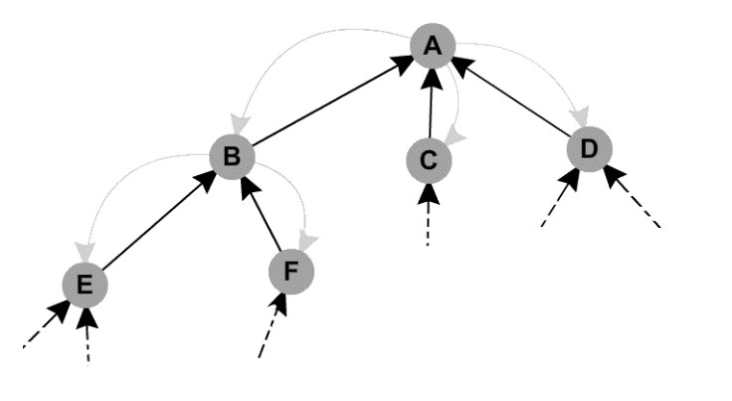

0 to 255

16 to 183

208 to 255

70%

10%

184 to 207

20%

27 to 151

152 to 182

80%

20%

### Figure 2: Example of hierarchical address assign- ment: (simplified) scenario with 8-bit available ad- dress space at the root and 6*.*25% of address reserve for delayed connections at each node.

After the address configuration phase, the network initial- ization is done. Each node has built the IPtree routing table with the address range of each child. All table entries are disjoint and sorted in increasing order of addresses. In this way, message forwarding can be performed in linear time using one comparison operation per table entry.

# Control plane: distributed tree structures

After the network is initialized and all nodes have received an IPv6 address range, three simultaneous distributed trees are maintained on all nodes in the 6LoWPAN: **Ctree:** the collection tree, maintained by the underlying collection pro- tocol (CTP/RPL). **IPtree:** the IPv6 address tree, built during the network initialization phase and kept static after- wards, except when new nodes join the network, in which case they receive an IPv6 range from the reserve space of the respective parent node in the collection tree. **RCtree:** the reverse collection tree, reflecting the dynamics of the collection tree in the reverse direction.

Initially, IPtree has the same topology as the reverse- collection tree *CtreeR*, and RCtree has no links (see Figure 3(a) and 3(b)).

*R*

of the subtree rooted at itself, and propagates it to its (pre-

*IPtree* = *Ctree*

and *RCtree* = *∅*

ferred) parent. Each node saves the number of descendants of each child.

Once the root has received the (aggregate) number of de- scendants of its *k* children, it partitions the available address space into *k* ranges of size proportional to the size of the sub- tree rooted at each child, leaving a portion of the space as reserve for possible late coming connections (see Figure 2). Each node repeats the address space partitioning procedure upon receiving its own address range from the parent and sends the proportional address ranges to the respective chil- dren, until all nodes have received an address. If a new node

Whenever a change occurs in one of the links in Ctree, the new link is added in the reverse direction into RCtree and maintained as long as this topology change persists (see Fig- ures 3(c) and 3(d)).

*RCtree* = *CtreeR \ IPtree*

Therefore, RCtree is not really a tree since it contains only the reversed links present in Ctree but not in IPtree. Nevertheless, its union with the “working” links in IPtree is, in fact, a tree, which is used in the alternative top-down

routing:

*RCtree ∪* (*IPtree ∩ CtreeR*) :alternative routing tree.

## 

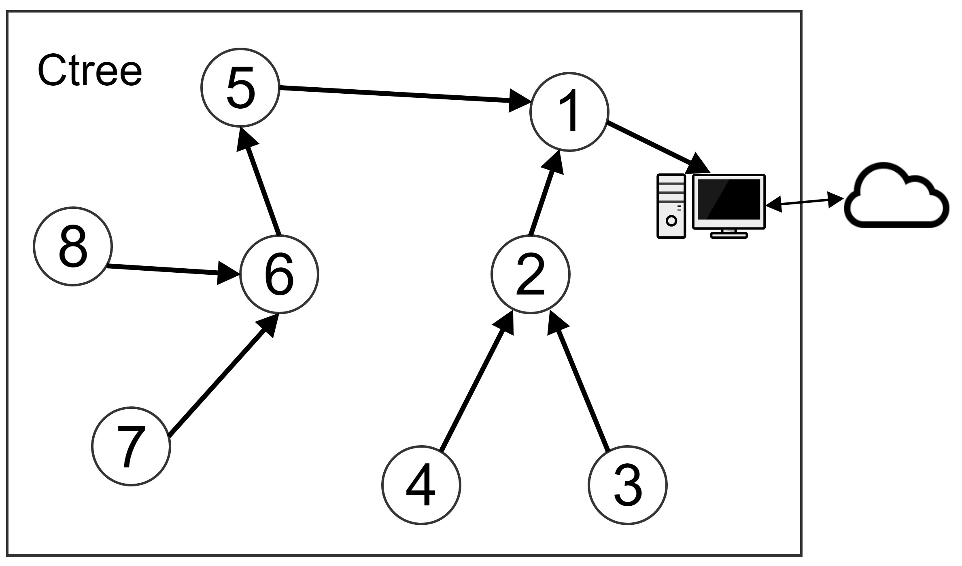

(a)

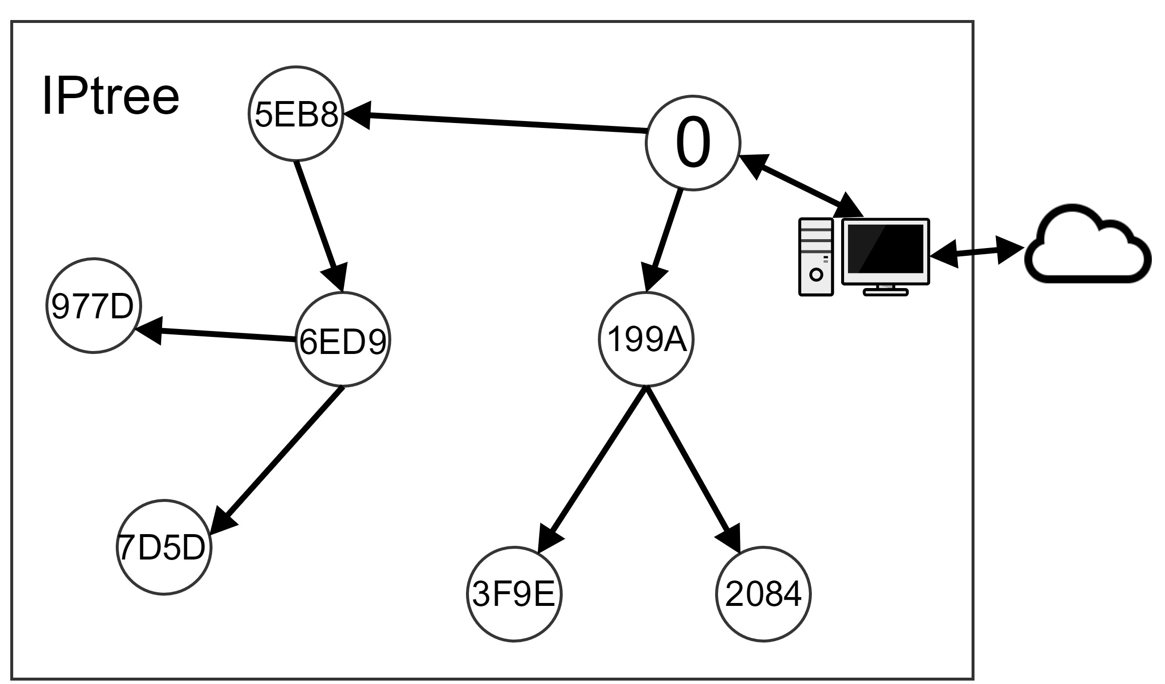

(b)

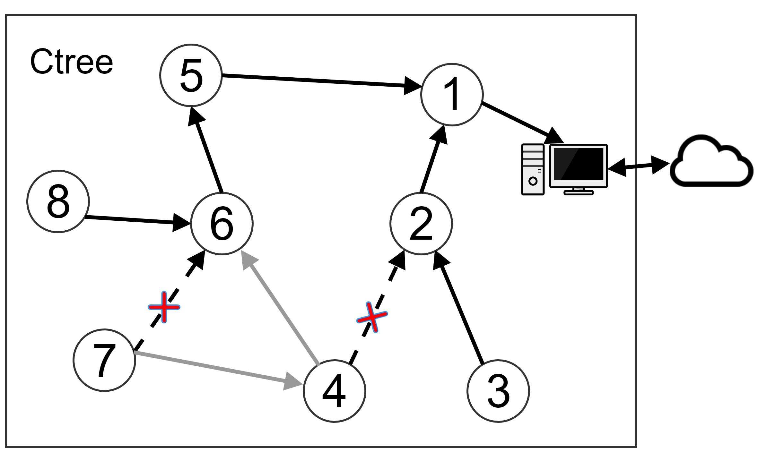 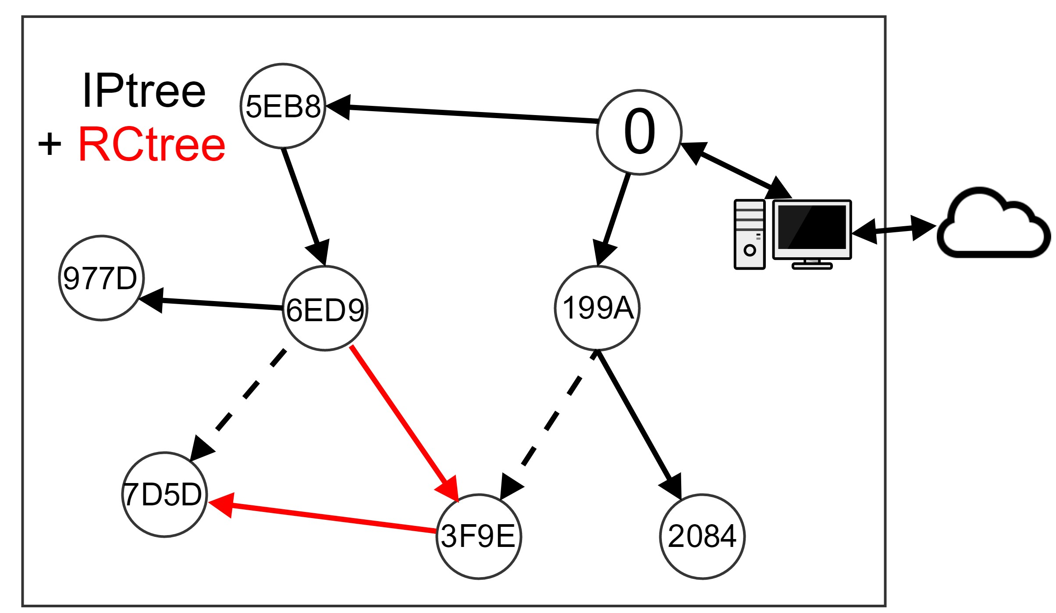

(c) (d)

### Figure 3: RCtree example: before and after two links change in the collection tree.

Each node *ni* maintains the following information:

* + - *CTparenti*: the ID of the current parent in the dy- namic collection tree;
    - *IParenti*: the ID of the node that assigned *ni* its IPv6 range initially *CTarenti* = *IParenti*);
    - *IPchildreni*: the *standard* (top-down) routing table, with address ranges of each one-hop descendent of *ni* in the IPtree;
    - *RChildreni*: the *alternative* (top-down) routing table, with address ranges of one-hop descendants in the RC- tree.

Note that, each node stores only one-hop neighborhood information, so the memory footprint is *O*(*k*), where *k* is the number of a node’s children at any given moment in time, which is optimal, considering that any (optimal) top- down routing mechanism would need at least one routing entry for every (current) child in the tree topology to reach all destinations.

The routing engine (see Figure 1) is responsible for creat- ing and maintaining the IPtree and RCtree routing tables. IPtree is created during the network initialization phase, while RCtree is updated dynamically to reflect changes in the network’s link qualities. Whenever a node *ni* has its *CTparenti* updated, and the current parent is different from

its *IParenti* (*IParenti /*= *CTparenti*), *ni* starts sending pe-

riodic beacons to its new parent, with regular intervals (in

our experiments, we set the beacon interval to *δ/*8, where *δ* is the maximum interval of the Trickle timer used in CTP). Upon receiving a beacon (from a new child in the collection tree), a node (*nj* = *CTparenti*) creates and keeps an entry in its alternative routing table *RChildrenj* with the IPv6 address range of the subtree of *ni*. As soon as *ni* stops us- ing *nj* as the preferred parent, it stops sending beacons to

*nj* . If no beacon is received from *ni* after 2 *×δ* ms, its (alter-

native) routing entry is deleted. Therefore, links in RCtree

are temporary and are deleted when not present in neither the collection nor the IP trees.

# Data plane: any-to-any routing

The forwarding engine (see Figure 1) is responsible for application packet forwarding. Any-to-any routing is per- formed by combining bottom-up forwarding, until the least common ancestor of sender and receiver, and then top-down forwarding until the destination. Upon receiving an applica-

tion layer packet, each node *ni* verifies whether the destina- tion IPv6 address falls within some range *j ∈ IPchildreni*:

if yes then the packet is forwarded (downwards) to node *nj* , otherwise, the packet is forwarded (upwards) to *CTparenti*. Note that, since each node has an IPv6 address, in contrast

to collection protocols, such as CTP and RPL, in Matrix, every node can act as a destination of messages originated inside and outside of the 6LoWPAN.

Each forwarded packet requests an acknowledgment from the next hop and can be retransmitted up to 30 times (sim- ilarly to what is done in CTP [6]). If thereafter no acknowl- edgment is received, then the node performs a *local broad- cast*, looking for an alternative next hop in the RCtree table of a (one-hop) neighbor. The *alternative routing* process is described in detail below.

# Fault tolerance and network dynamics

So why is Matrix robust to network dynamics? Note that, since routing is based on the hierarchical address allocation, if a node with the routing entries necessary to locate the next subtree becomes unreachable for longer than approxi- mately one second (failures that last less than 1s are effec- tively dealt with by retransmission mechanisms available in standard link layer protocols), messages with destinations in that subtree are dropped.

When a node or link fails or changes in Ctree, RCtree re- flects this change, and packets are forwarded from IPtree to RCtree via a local broadcast. The node that receives a local- broadcast checks in its RCtree whether it knows the subtree of the destination IPv6 address: if yes then is forwards the packet to the right subtree and the packet continues its path in the IPtree until the final destination.

Consider the following scenario: node X receives a packet with destination IPv6 address D (see Figure 4(a)). After

consulting its standard routing table *IP −childrenX* , X for- wards the packet to C. However, the link X *⇒* C fails, for

some reason, and C does not reply with an acknowledgment. Then, X makes a constant number (e.g., 30 times in CTP) of retransmission attempts. Meanwhile, since node C also lost its connection to X, it decides to change its parent in the collection tree to node A (see Figure 4(b)). Having changed its parent, C starts sending beacons to A, which creates

an entry in its alternative routing table *RC − childrenA*

for the subtree rooted at C, and keeps it as long as it re-

ceives periodic beacons from C (which will be done as long as *CTparentC* = A).

Having received no ack from C, X activates the *local broad- cast* mode: it sets the message’s type to“LB” and broadcasts it to all its one-hop neighbors (see Figure 4(c)). Upon re- ceiving the local broadcast, node A consults its alternative routing table and finds out that the destination address D falls within the IPv6 address range C. It then forwards the packet to C, from where the packets follows along its stan- dard route in the subtree of C (see Figure 4(d)).

## 

(a) (b)

## 

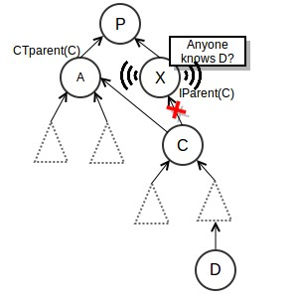

(c)

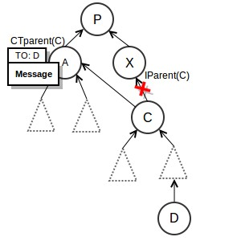

(d)

### Figure 4: Alternative top-down routing.

Note that this mechanism does not guarantee that the message will be delivered. If no one-hop neighbor of X had the address range of C in its alternative routing table, then the packet would be lost. Nevertheless, we argue that the probability that the message will be forwarded to the appro- priate subtree is high.

# Alternative routing: geometric rationale

The success of the local broadcast mechanism lies in the ability to forward messages top down along the IPtree, in spite of one or more link or node failures on the way. Matrix is designed to handle (non-adjacent) link or node failures and relies on a single local broadcast and temporary reverse collection links (RCtree).

Consider once again the scenario illustrated in Figure 4. When a node X is unable to forward a packet to the next hop, it activates the local broadcast mechanism, and it be- comes essential that one of X’s one-hop neighbors (in this case A) has replaced X as a parent of C in the collection tree. Therefore, given that the new parent of C is A, it becomes essential that X and A are neighbors. We argue that it is unlikely that this is not the case.

Our argument is of geometric nature. Since the considered 6LoWPAN is wireless, we show our argument in a unit disk graph (UDG) model [2]. We use the fact that the number of independent neighbors of any node in a UDG is bounded by a small constant, namely 5. The proof of this fact is sketched in Figure 5: consider a node X and its neighbor A. Any node located inside the gray region is a neighbor of both X and A, so any neighbor of X that is independent of (not adjacent to) A has to be outside the gray area and inside the circle around X. Let’s call this neighbor B. The next independent neighbor of X has to be located outside the 60 degree sector

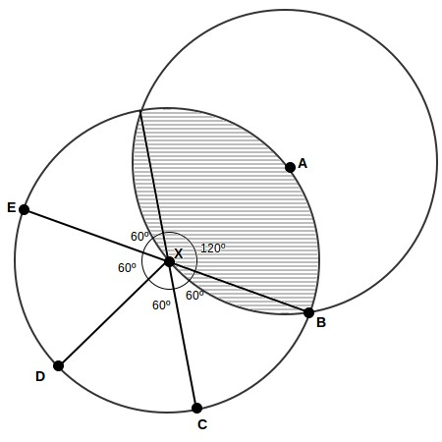

### Figure 5: UDG model: the number of independent neighbors of X is at most 5.

that starts at B, and so on. This procedure can be repeated no more than 5 times, before the 360 degrees around X are covered.

Given that the maximum number of neighbors that do not know each other is very small, for any possible node distribution and density around X, the probability that two neighbors of X are independent is low. In Figure 4(c), since both X and A are neighbors of C, the probability that they are themselves neighbors is high. Similar arguments can be used to back the effectiveness of the local broadcast mecha- nism when dealing with different non-adjacent link and node failures.

Note that this reasoning is only valid in an open space without obstacles and, even then, does not guarantee that the message will be delivered. Nevertheless, our experiments show that this intuition is in fact correct, and Matrix has a 95%–99% message delivery success in scenarios with node failures of increasing frequency and duration.

# COMPLEXITY ANALYSIS

In this section, we assume a synchronous communication model with point-to-point message passing. In this model, all nodes start executing the algorithm simultaneously and time is divided into synchronous rounds, i.e., when a message is sent from node *v* to its neighbor *u* at time-slot *t*, it must arrive at *u* before time-slot *t* + 1.

We first analyze the message and time complexity of the IPv6 address allocation phase of Matrix. Then, we look into the message complexity of the control plane of Matrix after the network initialization phase.

Note that Matrix requires that an underlying acyclic topol- ogy (Ctree) has been constructed by the network before the address allocation starts, i.e., every node knows who its par- ent in the Ctree is. Moreover, one of the building blocks of Matrix is the IPv6 multihop host configuration, performed by MHCL [15].

Theorem 1. *[15] For any network of size n with a span- ning collection tree Ctree rooted at node root, the message and time complexity of Matrix protocol in the address al- location phase is Msg*(*MatrixIP* (*Ctree, root*)) *= O*(*n*) *and Time*(*MatrixIP* (*T, root*)) *= O*(*depth*(*Ctree*))*, respectively. This message and time complexity is asymptotically optimal.*

Proof. The address allocation phase is comprised of a tree broadcast and a tree convergecast. In the broadcast

operation, a message (with address allocation information) must be sent to every node by the respective parent, which needs Ω(*n*) messages. Moreover the message sent by the root must reach every node at distance *depth*(*Ctree*) hops away, which needs Ω(*depth*(*Ctree*)) time-slots. Similarly, in the convergecast operation, every node must send a message to its parent after having received a message from its children, which needs Ω(*n*) messages. Also, a message sent by every

leaf node must reach the root, at distance *≤ depth*(*Ctree*),

which needs Ω(*depth*(*Ctree*)) time-slots.

Next, we examine the communication cost of the routines involved in the alternative routing, performed in the pres- ence of persistent node and link failures.

Theorem 2. *Consider a network with n nodes and a fail-*

The first scenario (*Scn*1) represents a network without node failures. The remaining scenarios represent a combination of values of *σ* and *ε*. Note that these are all node-failure scenarios, which are significantly harsher than models that simulate link or per-packet failures only.

On top of the network layer, we ran an application, in which each node sends 10 messages to the root, and the root relies with an ack. Nodes start sending application messages 90 seconds after the simulation has started. The entire simulation takes 20 minutes. Each simulation was run 10 times. In each plot, the curve or bars represent the average, and the error bars the confidence interval of 95%.

### Table 1: Simulation parameters Parameter Value

*ure event that causes LCT links to change in the collection*

*tree Ctree for at most* ∆ *ms. Moreover, consider a beacon interval of δ ms. The control message complexity of Matrix to perform alternative routing is Msg*(*MatrixRC* ) *= O*(*n*)*.*

Proof. Consider the *LCT* link changes in the collection tree Ctree. Note that *LCT* = *O*(*n*) since Ctree is acyclic and, therefore, has at most *n −* 1 links. Every link that

was changed must be inserted in the RCtree table of the respective (new) parent and kept during the interval ∆ using regularly sent beacons from the child to the parent. Given a beacon interval of *δ*, the total number of control messages

is bounded by ∆*/δ × LCT* = *O*(*n*).

Note that, in reality, the assumptions of synchrony and point-to-point message delivery do not hold in a 6LoWPAN. The moment in which each node joins the tree varies from node to node, such that nodes closer to the root tend to start executing the address allocation protocol earlier than nodes farther away from the root. Moreover, collisions, node and link failures can cause delays and prevent messages from being delivered. We analyze the performance of Matrix in an asynchronous model with collisions and transient node and link failures of variable duration through simulations in Section 4.

# EVALUATION

In this section, we evaluate the performance of Matrix through simulations.

# Simulation setup

Matrix was implemented as a subroutine of CTP in TinyOS [10] and the experiments were run using the TOSSIM sim- ulator [9]. We compare Matrix eith and without the local broadcast mechanism, to which we refer as MHCL (note that the implementation is different from that in [15], where it was implemented as a subroutine of RPL). RPL is imple- mented in Contiki [4] and was simulated on Cooja [5]. Table 1 lists the default simulation parameters used for each proto- col, in a non-faulty scenario. We use the *LinkLayerModel* tool from TinyOS to generate the topology and connectivity model.

We simulated a range of faulty scenarios, based on exper- imental data collected from TelosB sensor motes, deployed in an outdoor environment [1]. In each scenario, after ev- ery 60 seconds of simulation, each node shutdowns its radio

with probability *σ* and keeps the radio off for a time interval uniformly distributed in [*ε −* 5*, ε* + 5] seconds (see Table 2).

Base Station 1 center

Number of Nodes 100

Radio Range (*m*) 100

Density (*nodes/m*2) 10

Number of experiments 10

Path Loss Exponent 4.7

Power decay (dB) 55.4

Shadowing Std Dev (dB) 3.2

Simulation duration 20 min

Application messages (node to root + ack) 10 per node Max. Routing table size 20 entries

# Results

Firstly, we turn our attention to memory efficiency of each protocol. To evaluate the usage of routing tables, we com- pare the number of entries used by each protocol. Each node was allocated a routing table of equal maximum size: 20 entries. In Figure 6, we show the CDFs (cumulative dis- tribution functions) of the percentage of routing table usage among nodes3), and compare Matrix, RPL, and MHCL. In this plot, Matrix was simulated in the faulty scenario #10 (Table 2). Note that *>* 35% of nodes are leaves, i.e., do not have any descendants in the collection tree topology, and therefore use zero routing table entries. As we can see, RPL is the only protocol that uses 100% of table entries for

some nodes (*≥* 30% of nodes have their tables full). This is

due to the fact that RPL, in the storing mode, pro-actively

maintains an entry in the routing table of every node on the path from the root to each destination, which quickly fills the available memory and forces packets to be dropped. The difference between MHCL and Matrix is small: MHCL stores only the IPtree structure, whereas Matrix stores IP- tree and RCtree data; the latter is kept only temporarily during parent changes in the collection tree, so its average memory usage is low.

3We measured the routing table usage of each node in one- minute intervals, then took the average over 20 minutes.

### Table 2: Faulty network scenarios

|  |  |  |  |
| --- | --- | --- | --- |
| *σ\ε* | **10 sec.** | **20 sec.** | **40 sec.** |
| **1%** | Scenario 2 | Scenario 3 | Scenario 4 |
| **5%** | Scenario 5 | Scenario 6 | Scenario 7 |
| **10%** | Scenario 8 | Scenario 9 | Scenario 10 |

42.869

RPL

MHCL

MATRIX

CTP MATRIX

RPL

1.505 1.832

0.8

1.0

Code and memory footprint (Kb)

50

6.508

CDF nodes

0.4

0.6

0 10

16.204

30

23.45

RAM ROM

0.0

0.2

0 20 40 60 80 100

% Routing table usage

### Figure 6: Routing table usage CDF. (Maximum ta- ble size = 20)

Figure 7 illustrates the amount of control traffic in our experiments (the total number of beacons sent during the entire simulation). Matrix sends fewer control packet than RPL, because it only sends additional beacons during net- work initialization and in case of collection tree topology up- dates, whereas RPL has a communication intensive mainte- nance of downward routes during the entire execution time.

### Figure 8: Code and memory footprint in bytes.

loss was inevitable. The remaining messages were lost due to wireless collisions and node failures on the packet’s path. We can see that, when a valid path exists to the desti- nation, the top-down success rate of Matrix varies between 95% and 99%. In the harshest faulty scenario 10, without the local broadcast mechanism, MHCL delivers 85% of top- down messages. With the local broadcast activated, the suc- cess rate increases to 95%, i.e., roughly 2/3 of otherwise lost messages succeed in reaching the final destination. RPL, on the other hand, delivered less than 20% of messages in all simulated scenarios, which occurs due to lack of memory to

store all the top-down routes.

10000

MATRIX CTP RPL

−

−

−

−

−

−

−

−

−

−

−

−

−

−

− −

−

−

− − −

−

−

−

− −

− −

−

−

Sc 1 Sc 2 Sc 3 Sc 4 Sc 5 Sc 6 Sc 7 Sc 8 Sc 9 Sc 10 Scenarios

Number of Beacons

0

2000

6000

Top−down success rate (%)

20 40 60 80 100

Sc 1 Sc 2 Sc 3 Sc 4 Sc 5 Sc 6 Sc 7 Sc 8 Sc 9 Sc 10 Scenarios



−

RIX CL

itable

osses

− − − − −

−

− −

−

−

MAT MH RPL

Inev l

0

### Figure 7: Number of control packets.

Figure 8 compares RAM and ROM footprints in the proto- col stack of CTP, RPL and Matrix. We can see that Matrix adds only a little more than 7KB of code to CTP, allow- ing this protocol to perform any-to-any communication with high scalability. When compared with RPL, the execution code of Matrix requires less RAM.

Our main result is illustrated in Figure 9, which com- pares top-down routing success rate. We measured the total number of application (ack) messages sent downwards and successfully received by the destination.4 In the plot, “in- evitable losses” refers to the number of messages that were lost due to a failure of the destination node, in which case, there were no valid path to the destination and the packet

4We do not plot the success rate of bottom-up traffic, since it is done by the underlying collection protocol, without any intervention from Matrix.

### Figure 9: Top-down routing success rate.

1. **RELATED WORK**

AODV[17] and DSR[7] are traditional wireless protocols that allow any-to-any communication, but they were de- signed for 802.11 and require too many states or apply sev- eral overheads on the packet header. In the context of low- power and lossy networks, CTP[6] and CodeDrip[8] were de- signed for bottom-up and top-down data flows, respectively. They support communication in only one direction.

State-of-the-art routing protocols for 6lowPAN that en- able any-to-any communication are RPL[19], XCTP[18], and Hydro[3]. RPL allows two modes of operation (storing and non-storing) for downwards data flows. The non-storing mode is based on source routing, and the storing mode pro- actively maintains an entry in the routing table of every

node on the path from the root to each destination, which is not scalable to even moderate-size networks. XCTP is an extension of CTP and is based on a reactive reverse collec- tion route creating between the root and every source node. An entry in the reverse-route table is kept for every data flow at each node on the path between the source and the destination, which is also not scalable in terms of memory footprint. Hydro protocol, like RPL, is based on a DAG (di- rected acyclic graph) for bottom-up communication. Source nodes need to periodically send reports to the border router, which builds a global view (typically incomplete) of the net- work topology.

Some more recent protocols [14, 13, 12] modified RPL to include new features. In [14], a load-balance technique is applied over nodes to decrease power consumption. In [13, 12], they provide multi-path routing protocols to improve throughput and fault tolerance.

Matrix differs from previous work by providing a reliable and scalable solution for any-to-any routing in 6LoWLAN, both in terms of routing table size and control message over- head. Moreover, it allocates global and structured IPv6 ad- dresses to all nodes, which allow nodes to act as destinations integrated into the Internet, contributing to the realization of the Internet of Things.

# CONCLUSIONS

In this paper, we propose Matrix: a novel routing proto- col that is built upon a data collection structure and is com- prised of two phases: (1) network initialization, in which hierarchical IPv6 addresses, which reflect the topology of the underlying wireless network, are assigned to nodes in a multihop way; and (2) reliable any-to-any communication, which enables message and memory-efficient implementation of a wide range of new applications for 6LoWPAN.

# REFERENCES

[1] N. Baccour, A. Koubaˆa, L. Mottola, M. A. Zu´n˜iga,

H. Youssef, C. A. Boano, and M. Alves. Radio link quality estimation in wireless sensor networks: A survey. *ACM Trans. Sen. Netw.*, 8(4):34:1–34:33, Sept. 2012.

[2] B. N. Clark, C. J. Colbourn, and D. S. Johnson. Unit disk graphs. *Discrete Math.*, 86(1-3):165–177, Jan.

1991.

[3] S. Dawson-Haggerty, A. Tavakoli, and D. Culler.

Hydro: A hybrid routing protocol for low-power and lossy networks. In *Smart Grid Communications (SmartGridComm)*. IEEE, 2010.

[4] A. Dunkels, B. Gronvall, and T. Voigt. Contiki - a lightweight and flexible operating system for tiny networked sensors. In *IEEE LCN*, pages 455–462, Washington, DC, USA, 2004. IEEE Computer Society.

[5] J. Eriksson, F. O¨ sterlind, N. Finne, N. Tsiftes,

A. Dunkels, T. Voigt, R. Sauter, and P. J. Marr´on. Cooja/mspsim: Interoperability testing for wireless sensor networks. In *Proceedings of the 2Nd International Conference on Simulation Tools and Techniques*, Simutools’09, pages 27:1–27:7, 2009.

[6] O. Gnawali, R. Fonseca, K. Jamieson, D. Moss, and

P. Levis. Collection tree protocol. In *Proceedings of the 7th ACM Conference on Embedded Networked Sensor Systems*, SenSys ’09, pages 1–14, 2009.

[7] D. Johnson, Y. Hu, and D. Maltz. The dynamic source routing protocol (DSR) for mobile ad hoc networks for IPV4. *RFC: 4728*, 2007.

[8] N. d. S. R. Ju´nior, M. A. Vieira, L. F. Vieira, and

O. Gnawali. Codedrip: Data dissemination protocol with network coding for wireless sensor networks. In *Wireless Sensor Networks*, pages 34–49. Springer, 2014.

[9] P. Levis, N. Lee, M. Welsh, and D. Culler. Tossim: Accurate and scalable simulation of entire tinyos applications. In *Proceedings of the 1st International Conference on Embedded Networked Sensor Systems*, SenSys ’03, pages 126–137, New York, NY, USA, 2003. ACM.

[10] P. Levis, S. Madden, J. Polastre, R. Szewczyk,

K. Whitehouse, A. Woo, D. Gay, J. Hill, M. Welsh,

E. Brewer, et al. Tinyos: An operating system for sensor networks. In *Ambient intelligence*. Springer, 2005.

[11] P. Levis, N. Patel, D. Culler, and S. Shenker. Trickle: A self-regulating algorithm for code propagation and maintenance in wireless sensor networks. In *Proceedings of the 1st Conference on Symposium on Networked Systems Design and Implementation - Volume 1*, NSDI’04, pages 2–2, 2004.

[12] M. A. Lodhi, A. Rehman, M. M. Khan, and F. B. Hussain. Multiple path rpl for low power lossy networks. In *Wireless and Mobile (APWiMob), 2015 IEEE Asia Pacific Conference on*, pages 279–284, Aug 2015.

[13] M. N. Moghadam, H. Taheri, and M. Karrari.

Multi-class multipath routing protocol for low power wireless networks with heuristic optimal load distribution. *Wirel. Pers. Commun.*, 82(2):861–881, May 2015.

[14] U. Palani, V. Alamelumangai, and A. Nachiappan.

Hybrid routing and load balancing protocol for wireless sensor network. *Wireless Networks*, pages 1–8, 2015.

[15] B. Peres and O. Goussevskaia. MHCL: IPv6 Multihop Host Configuration for Low-Power Wireless Networks . [http://arxiv.org/abs/1606.02674,](http://arxiv.org/abs/1606.02674) 2016.

[16] B. S. Peres and O. Goussevskaia. Alocacao de Enderecos IPv6 em Redes Multi-hop de Radios de Baixa Potencia. In *Computer Networks and Distributed Systems (SBRC), 2015 Brazilian Symposium on*, May 2015.

[17] C. Perkins, E. Belding-Royer, and S. Das. Ad hoc on demand distance vector (AODV) routing (RFC 3561). *IETF MANET Working Group*, 2003.

[18] B. P. Santos, M. A. Vieira, and L. F. Vieira. extend collection tree protocol. In *Wireless Communications and Networking Conference (WCNC), 2015 IEEE*, pages 1512–1517, March 2015.

[19] T. Winter, P. Thubert, A. Brandt, J. Hui, R. Kelsey,

P. Levis, K. Pister, R. Struik, J. Vasseur, and

R. Alexander. RPL: IPv6 Routing Protocol for

Low-Power and Lossy Networks. RFC 6550 (Proposed Standard), 2012.